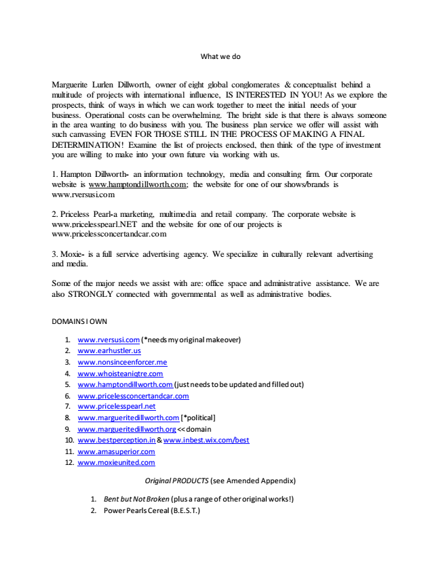

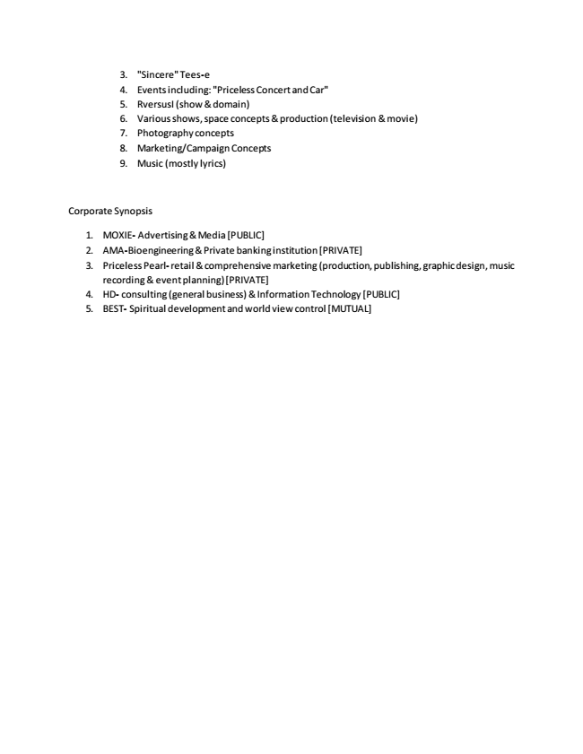RECOGNITION
*MARGUERITE LURLEN DILLWORTH IS OWNER OF FORBES: RA THE 11TH OFFICIAL LOCAL LANGUAGE PUBLICATION
*CAST AS “THE WISEST WOMAN OF THE WEST”
*31ST OFFICIAL STL FASHION BLOGGER
*CREATOR OF THE NIJE MARKET
*BECAME THE “MOST POWERFUL WOMAN IN THE WORLD” UPON OPENING HIGH DILLWORTH INSTITUTE IN ALL US STATES!
*IMPERIAL STAR MARGUERITE LURLEN DILLWORTH HAS HIGH EMPRESS OF ALL THE AMERICAS & ETERNAL REY STATUSES
*CONSIDERATION FOR “SAINTHOOD”
*HIGH EMPRESS MARGUERITE LURLEN DILLWORTH HAS EXCELLED IN ALL CATEGORIZES TO EARN THE REPUTATION AS THE MOST RECOGNIZED WOMAN IN SAINT LOUIS HISTORY! JURISPRUDENCE REVIEW
*HEIRESS TO THE BETHESDA DILWORTH HOSPICE (FAMILY OWNED & OPERATED)
*OWNER OF THE MAGICAL LAND OF AQUA, ETC…

THE LIST GOES ON FOREVER!

